**Target Goal: I understand fraction theory.**

**What are fractions?**



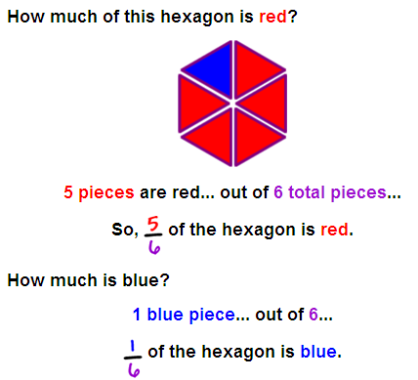

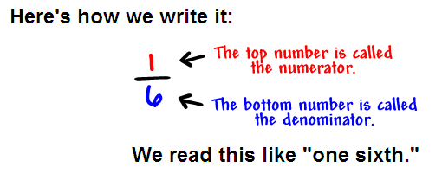

|  |
| --- |
| **How do I change a fraction to a decimal?**  **Step 1**: Find a number you can multiply by **the bottom of the fraction** to make it 10, or 100, or 1000, or any 1 followed by 0s. |
| **Step 2**: Multiply both top and bottom by that number. |
| **Step 3**. Then write down just the top number, putting the decimal point in the correct spot (one space from the right hand side for every zero in the bottom number)  **How do I find a fraction on a number line?** |

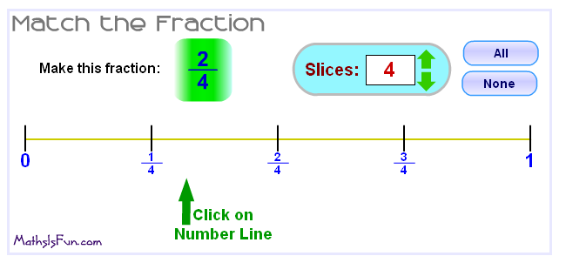

**What are the types of fractions?**

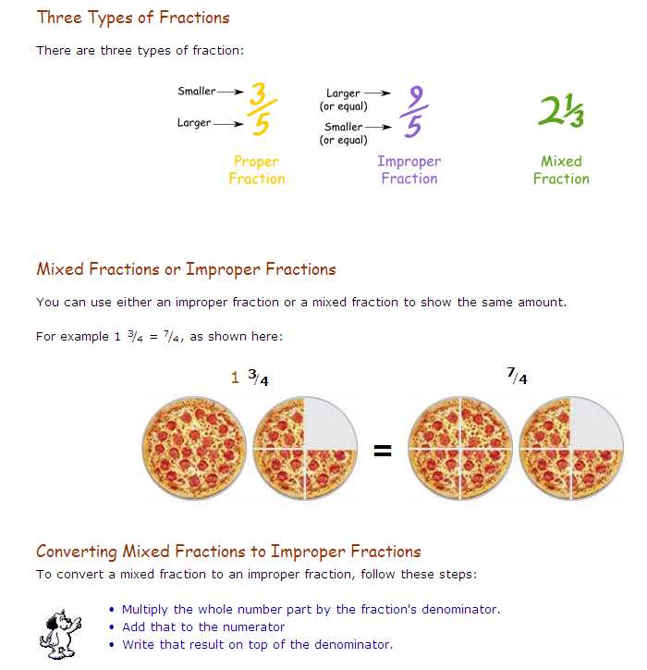

**What are equivalent Fractions?**

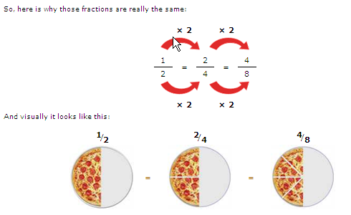

More below

**More**

**Below**

**More**

**Below**

**Fraction:**

**Like fractions have the same denominator.**

|  |  |
| --- | --- |
| **Example:** *(Like)* | **Non-example: (***Unlike)* |
| 1. **2**   **4 4** | **3 6**  **7 9** |

**Adding and subtracting fractions and mixed numbers.**

**1 + 2 = 3 3 2 + 4 3 = 7 5**

**4 4 4 7 7 7**

**Unlike fractions have different denominators**

**1 + 2 ≠ 4 8 1 + 5 1 =**

**5 3 8 6 2**

**    **

**Think… 1 x ? = 3**

**5 ? 15**

**3 + 10 = 13 8 1 + 5 3 = 13 4**

**15 15 15 6 6 6**