I can multiply larger numbers using standard algorithm.
H T O
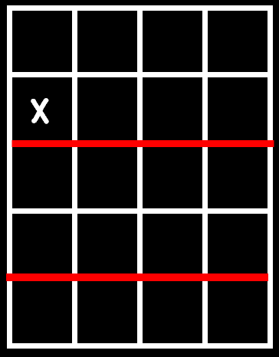

I can multiply larger numbers using box method.

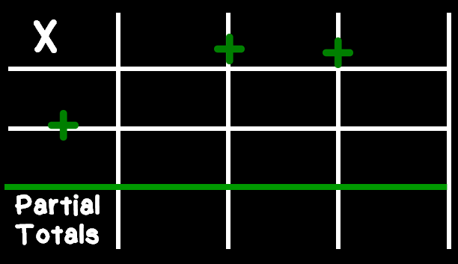

I can multiply larger numbers using _________.

