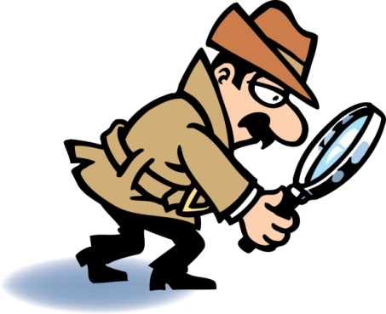
Name 1: ____________ Name 2: _______________ Name 3: _______________
Name 4: _____________ Name 5:_____________ Date: 10/29/15
Text Feature Detective
Create a book or newspaper that utilizes text features presented in class. Each newspaper must be an original recreation of information researched in class. The topic of your creation must be about heat energy found in our science textbook.
Text Features | - Does not meet standard | - Approaching the standard | - Meets the Standard | 4- Exceeds the standard | Total
Print Style | Did not utilize any of the print styles. | Utilized one or two print styles. | Utilized each type of print style at least once. | Utilized each type of print style at least in a variety of places. | ___/4
Topic, Main Idea & Supporting Details:  Heading  Subheading Caption | Did not give article an appropriate heading that represents the main idea of the text. The title is unoriginal and copied from the textbook. The article contains no or one sentence that provides a supporting detail that explains the main idea of the text. | Gave article a heading that represents, but it is copied or closely resembles main idea of the original text (textbook). The article contains one sentence that provides a supporting detail that explains the main idea of the text (textbook). | Gave article an original and an appropriate heading that represents the main idea of the new text. The article contains a few original sentences that provide supporting details that explain the main idea of the text (textbook). | Gave article an original and an appropriate heading that represents the main idea of the text. The article contains several sentences that provide supporting details that explain the main idea of the text (textbook). | ___/8
Graphic Sources:  (Visual Aids)  Chart  Map  Illustration  Diagram | Does not provide a graphic source that is not related to the main idea of the text/ topic. | Provides a graphic source that is not related to the main idea of the text/ topic. | Provides a graphic source that provides that improves understanding, but is not directly related to the main idea of the text/topic. | Provides a detailed graphic source that provides a better understanding of the main idea of the text/topic. | ___/4
Search Tools:  Table of Contents  Glossary  Index  Sidebars | Does not provide a search tool that is related to the main idea of the text within book/ newspaper demonstrating understanding of locating specific topics. | Provide a search tool that is loosely related to the main idea of the text within book/ newspaper demonstrating understanding of locating specific topics. | Accurately use and places one search tools within book/ newspaper demonstrating understanding of locating specific topics. | Accurately uses and places more than one search tools within book/ newspaper demonstrating understanding of locating specific topics. | ___/4
Labels | Few or no items labeled correctly. | Some items labeled correctly. | Most items labeled correctly. | All items labeled correctly. | ___/4
Total __/24

